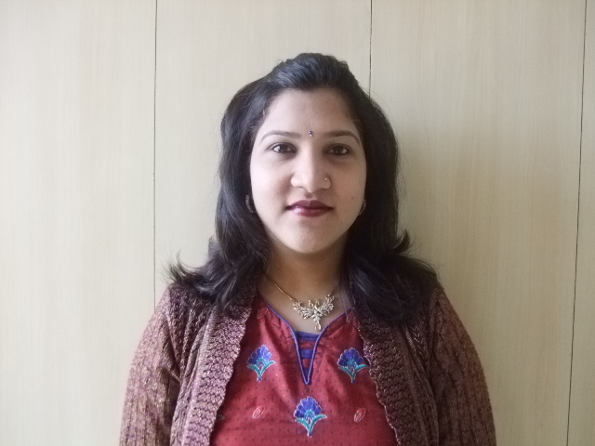
ANNU BHARTI
B-6/92, BHAJAN PURA,
DELHI-110053.
MOBILE- 9971344205
E-MAIL ID-anubharti85@yahoo.in

Objective :

Seeking an opportunity to utilize my skills, ability, caliber and experience in an environment that offers professional growth.

Educational Qualifications:
- Graduate from Delhi University in 2008.

Professional Qualifications:
- One year professional diploma in Software Engg. & Web Designing from F-Tech Institute at Yamuna Vihar in 2002.
- One month Tally (version 5.4) from NIIT Institute at Yamuna Vihar in 2003.
- Two months Tally Graduate (version 6.3) from Attitude at Yamuna Vihar in 2004.
- Certificate course in Library Science from Delhi Library Association at Naraina in 2006.

Work Experience:

Worked in Sant Parmanand Hospital, since March 2007 to July 2015.

- Worked in Medicine Reception from Mar 2007 to Mar 2008

- Billing & Patient interaction
- Prepared discharge summary of patients of various specialties.
- Coordinate with doctors for re: follow up appointments.

- Independently handled the work of Quarterly Continuing Medical Education(C.M.E) Conference in the hospital from Apr 2008 to Dec 2008.

- Worked in Executive Health Check Package from Jan 2009 to March 2013.
- Promote Health Package services for National & International patients
- Answer enquiries of patients
- Ensure arrangement for patients
- Manage patient complaints and follow up with service recovery if necessary
- Make new clients, motivate them and generate maximum business out of them
- Coordinate appointments with doctors
- Maintain records

- Worked in Radiology Department from Apr 2013 to July 2015.

- Preparing documentation work of color doppler and x-ray
- Attending calls and making appointments
- Maintain monthly record of cases performed in the department
- Managing all Secretarial work of doctors
- Coordinate with doctors
- Schedule & coordinate appointments and events.
- Enter the patients information into the computer system
- Maintain records & financial data
- Audit checking between the manual forms & system inputs
- Filing of documents
- Office management

Experience:
- Lab Instructor in F-Tech Institute at Yamuna Vihar in 2000.
- English Faculty in F-Tech Institute at Yamuna Vihar in 2002.
- Counselor & English Faculty in Pragati Education Point at Yamuna Vihar in 2004.
- English Faculty in C-Tech Institute of Hardware & Chip Level at Yamuna Vihar in 2005.
- Worked in Sant Parmanand Hospital at Civil Lines since March 2007 to July 2015.

Notable Credits:

- Honored by the HOD of Health Package Department of SPH for smooth functioning of the Health Package System.

- Honored by the Director Medical of SPH for converting maximum package queries into business.

- My way of work has been appreciated by esteemed doctors of SPH.

- I have heard words of praise from everyone including management members of SPH.

Personal Skills: Loyalty, Hard Work, Adaptability, Positive Attitude.

Professional Skills: Coordinating & organizational skills, patient counseling expert,

secretarial skill, client management.

Personal strengths: Organized, dedicated, attentive

Professional Strengths: Focused on growth, team work, multitasking, stress management

Personal Details:

Father’s Name Mr. Inderjeet Kumar
Date of Birth 26th August, 1985
Hobbies Traveling, Reading & Painting.
Marital Status Single Parent
Religion Hindu
Languages Known English /Hindi

Date:
Place: Delhi.
(ANNU BHARTI)
References

Dr. George Mathai (MD)
Sr. Consultant Int. Medicine
Sant Parmanand Hospital
Civil Lines, Delhi.
Ph. No. 9810057974

Dr. Lalit Kumar Mehta (MD)
HOD of Health Package Department
Sant Parmanand Hospital
Civil Lines, Delhi.
Ph. No. 9810100756

