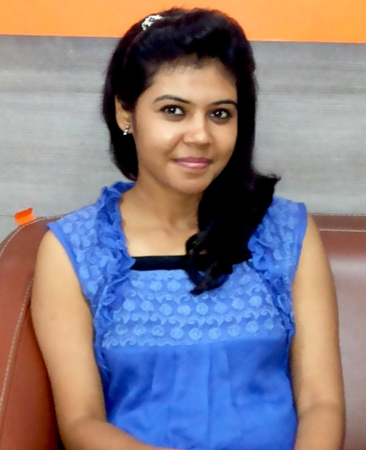  Permanent Address:  37 M.D ROAD, Dum Dum Cantoment, Kolkata-700028  Current Address:  C- 140, 3rd floor,  Avantika, Rohini-85  Mobile:  +91-9953544557  E-Mail:  bittuaruna@gmail.com  Personal Data:  Date of Birth : 22.03.1986  Gender : Female  Nationality : Indian  Marital Status : Married  Languages Known:  Hindi, English and Bengali  Interests :  Listening Music,  Reading (fictions and motivational) | ARUNA SINGH  Career Objective  .  To evolve as a learning individual and leverage it to create value for my organization.  tT  ACADEMIC QUALIFICATIONS  STRENGHTS  - Energetic, responsible and able to work hard as per requirement, good representative while working in a group. Good listener  SELF ASSESSMENT  - Nature – Persistent, Simple and Caring.  - Strengths – Capacity to focus on work, Goal oriented and Confident.  TECHNICAL QULIFICATIONS  - Diploma in information technology application from STATE YOUTH CENTER (W.B. Govt.) with grade ‘A’  EXPERIENCE  - Worked with Vasan Eye Care (India Largest Eye Care Network) 2 years as a Front Office Executive in Kohat Enclave Pitampura.  - Working with Centre for Sight (Asia’s Largest LASIK Network) Last 11 Month as a Sr. Billing Executive in Fortis Escorts Okhla.  I certify that information given above is true to the best of my knowledge.  (Aruna Singh)
  DEGREE | BOARD/  UNIVERSITY | YEAR | PERCENTAGE
  PERSUING MBA  (Hospital Management)  PGDHA-Hospital Administration | APOLLO MEDVARSITY  APOLLO MEDVARSITY | 2015  2011-12 | A Grade
  B.Sc.  (Bio Science ) | CALCUTTA UNIVERSITY | 2006-09 | 56
  12th | W.B Board | 2006 | 55
  10th | W.B Board | 2003 | 65

