Curriculum Vitae
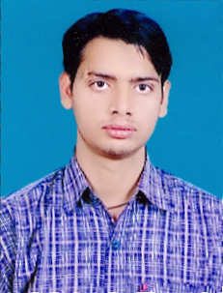
ABHILASH KUMAR
plot no-d-27
fourth lane vrindawan vihar
gaushala road ,balaganj
( behind eras hospital )
chowk
luclnow 226003
Contact No:-09161861037
Email Id:- Abhilash.761@Rediffmail.Com

Career Objective:-
To Be Part Of An Organization That Offers A Challenging, Stimulating, Learning Environment To
Work And Provides Scope For Individual Development And Offers Attractive Prospects For Long- Term Personal Development, Development And Career Growth.

Education Qualification:-
B.C.A- FROM ALAGAPPA UNIVERSITY KARAIKUDI TAMILNADU. In 2011
Intermediate:- From U.P In 2007. 1st Div.
High School:- From U.P Board In 2005. 1st Div.

Professional Qualification:-
Diploma In Computer Hardware & Networking
Certificate in Office Automaion and Internet
Extra Activity:-
Computer Operator,
And Data Operator
Internet, Ms-OFFICE ETC.
Type WRITER IN ENGLISH And Hindi.
Experience In Data Operator
And Speak English AND HINDI

Experience: 1- 4 Months Work in (DCO) data collection officer at ezeead.com
2- 4 months experience in data entry operator in census 2011 ( government project tie up with karvy ltd.)
Project:-
6 month HANDLING CCTNS PILOT Project In Wipro
Crime & Criminal Tracking Network & Systems (Cctns-2011)
Crime & Criminal Tracking
Network and Systems (CCTNS 2011)
E-Governance Mission Mode Project (MMP) of MHA GoI

Personal Detail:-
Father’s Name Hans raj Seth
Date Of Birth 22/12/1989
Gender Male
Hobbies Reading Magazine, News Paper& Listening Music
Nationality Indian
Language Known Hindi & English
Permanent Address d-27 fourth lane vrindawan vihar colony
gausala road balaganj
behind eras hospital
chowk lucknow
Dist:- lucknow . Uttar Pradesh
mo- 9161861037
Declaration:-
I Hereby Declare That Above Mentioned Information Details Are True
To Best Of My Knowledge. If Given A Chance I Will Prove My Worth To The Organization.

date :-
Place…………lucknow…….. Abhilash Kumar

