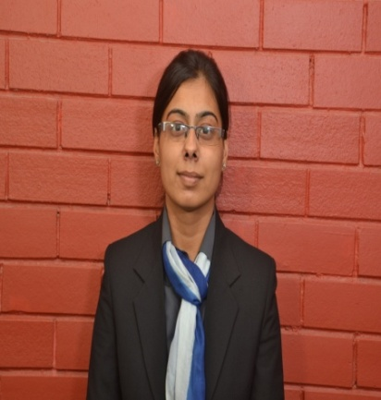


Supriya Malhotra

Mobile No: - 9953237897
Email: -supriyamalhotra176@gmail.com
Correspondence address: - 3255 Second Floor, Mahindra Park, Rani Bagh,
Delhi-110034

CAREER OBJECTIVE

To work in an organisation which provides opportunity for self development, where an individual can achieve personnel as well as organisational goals.

EDUCATION / ACADEMICS

Educational Qualification | University/College/School | Year | Percentage
PGDM | New Delhi Institute Of Management | 2013-15 | 65
BBA | Delhi College Of Advanced Studies (GGSIP University) | 2010-13 | 85
Higher Secondary | Crescent Public School, Pitampura | 2010 | 74
Secondary | Crescent Public School, Pitampura | 2008 | 80

INTERNSHIP

Firm Name : Ayurvet Limited
Project Title : A study on Performance Management System at Ayurvet Limited
Duration : 2 months
Core responsibilities

- Filling appraisal form of the field workers based on various parameters.
- Grading the employees according to the marks obtained.
- Verifying the grading in employee appraisal forms with the records.
- Verifying the annual appraisal forms.
- Correcting the appraisal letter of field managers.
- Conducting telephonic interviews for the post of vertinary sales officer.
- Conducting survey in the organization regarding their satisfaction with PMS.

PROJECTS

1. Firm Name : KPMG
Duration : 5 Days
Core Responsibilities
- Coordinating with participants and assessors.
- Preparing assessment reports of the participants.
2. Firm Name : Leuphana University Luneburg
Duration : 1 Month
Project Title : Research on Organisational Changes
Core Responsibilities
- Getting questionnaires filled by working professionals.
- Filling up the received information in an online database
ACHIEVEMENTS / AWARDS/ RECOGNITION

- Award winner for securing Second position at Graduation Level.
- Award winner for securing 73% marks by Academy Of Geography Teachers, Delhi (Regd.) .
- Award winner by Avantika International Talent Search Painting Competition, Satish Gujral Certificate.
CO-CURRICULAR / EXTRA-CURRICULAR ACTIVITIES

- Member of NHRDN
- Attended National Seminar on “New Paradigm in Marketing and Strategies for Future.
- Certificate of participation in the Investor Awareness Programme on “Understanding The Capital Market” by Northern India Regional Council of The Institute of Company Secretaries of India.
- Volunteered at NHRDN 2nd National Summit on HR & Social Media.
AREA OF SPECIALIZATION

Human Resource (Major 1)
Marketing (Major 2)

COMPUTER PROFICIENCY

- MS Office :- ( MS Excel, MS Word, MS Powerpoint ) Web Programming :- HTML

PERSONAL INFORMATION
Date of Birth : 17th June 1992
Gender : Female
Marital Status : Single

